(2x2) Filter PM Fiber Standard Coupler

Features
- Low Insertion Loss
- Low Extinction Ratio
- Available for Slow Only or Fast Axis App
- High Stability and Reliability

Applications
- EDFA
- Fiber Optical Instrument
- Coherent Communication
- Power Monitoring
- Fiber Sensor

Specifications

Parameters | Unit | Value
Operating Wavelength | nm | 1550
Operating Bandwidth | nm | +/-40
Splitting Ratio | dB | 10/90
Insertion loss | dB | ≤11.3/1.0
Typical Excess Loss | dB | ≤0.7
Uniformity | dB | ≤0.5
Polarization Extinction Ratio | dB | ≥22
Return Loss | dB | ≥55
Power Handling | mW | ≤300

Directivity |  | dB | ≥55
Operating Temperature |  | ℃ | -5~+65
Storage Temperature |  | ℃ | -40～+80
Port Type |  | / | 2x2;
Fiber Type |  | / | Corning Panda fiber
Fiber Length |  | m | 1.0±0.05
Connector |  | / | FC/APC
Package  Dimension | 900μm Loose  Tube | mm | Φ5.5×38

For device with connector, IL is 0.3dB higher, RL is 5dB lower, ER is 2dB lower. The default connector key is aligned to slow axis.

- Package Dimension

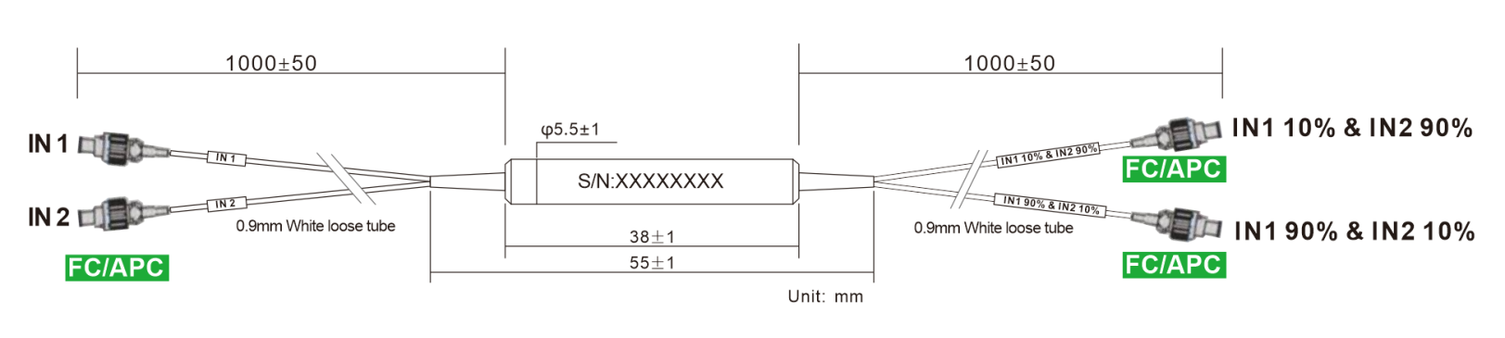

- Ordering information
Coup er | - | XXX | XXX | XX | XXX | XX | XX | - | X | X
 |  | Port NO | Wavelength | Splitting Ratio | Modules type | Fiber Type | Fiber Length |  | Com connector | Port Connector
PMC= PM  Coupler |  | 12=1X2 | 131=1310nm | 50=50/50 | ST1=Ф5.5X35 | 02=250um fiber | 10=1.0m |  | 0=None | 0=None
PMC= PM  Coupler |  | 22=2X2 | 155=1550nm | 10=10/90 | ST2=Ф5.5X38 | 09=0.9mm Tube | XX=Customized |  | 1=FC/UPC | 1=FC/UPC
PMC= PM  Coupler |  |  | 980=980nm | 01=01/99 | SB=90 X20 X10 | 20=2.0mm Tube |  |  | 2=FC/APC | 2=FC/APC
 |  |  | 106=1064nm |  | XX=Customized | 30=3.0mm Tube |  |  | 3=SC/UPC | 3=SC/UPC
 |  |  | 780=780nm |  |  | XX=Customized |  |  | 4=SC/APC | 4=SC/APC
 |  |  |  |  |  |  |  |  | 5=LC/UPC | 5=LC/UPC
 |  |  |  |  |  |  |  |  | 6=LC/APC | 6=LC/APC
 |  |  |  |  |  |  |  |  | X=Customized | X=Customized

Part Number | Product Description
PMC-2215510ST20910-22(S) | 2*2 Filter PM Fiber Coupler，Splitting Ratio 10/90, Steel Tube type, PM 1550nm Panda fiber With 0.9mm Hytrel White Tube,  fiber Length 1m (with connector)， connector FC/APC，  connector key is aligned to slow axis.

